COVID-19 Cases Tracker Using COVID-19 Coronavirus Statistics API Report

# INTRODUCTION

To understand the scale of the COVID-19 outbreak, and respond appropriately, we would want to know how many people are infected by COVID-19 to analyse the mortality risk of the COVID-19 outbreak. While governments across the globe are working in collaboration with local authorities and health-care providers to track, respond, and prevent the spread of disease caused by the coronavirus. This project aims at working with an API through which a visualization dashboard for COVID-19 statistics can be developed.

# PROCEDURE

The first task is to begin with a powerful API. This is achieved through RAPID API which has numerous options to choose an API for any category. In this case, we require a COVID19 Statistics API which shows the appropriate number of reported cases, recovered and the number of deaths in a given country. After copying the code snippet in Python-Requests, next task is to write the code in python. We import flask and other libraries; we will use the declared constructor to route to the HTML page. We have 3 html pages in the templates folder for the frontend section. We also one image in static folder for our UI. We write a function for the output and add the API code snippet in it. We write 3 more functions for routing of the HTML pages. The statistics function extracts the values of confirmed, deaths & recovered cases.At the last, we call the main function to run the application in the localhost.

# RESULTS

to run the application, open command prompt or anaconda prompt, Navigate to the folder where python code file resides. Now type the "python hello.py" command.It will show the local host where the app is running on "http://127.0.0.1.5000/" or "localhost:5000"

copy that localhost URL and open that URL in browser. It does navigate to the web page.

# OUTPUT

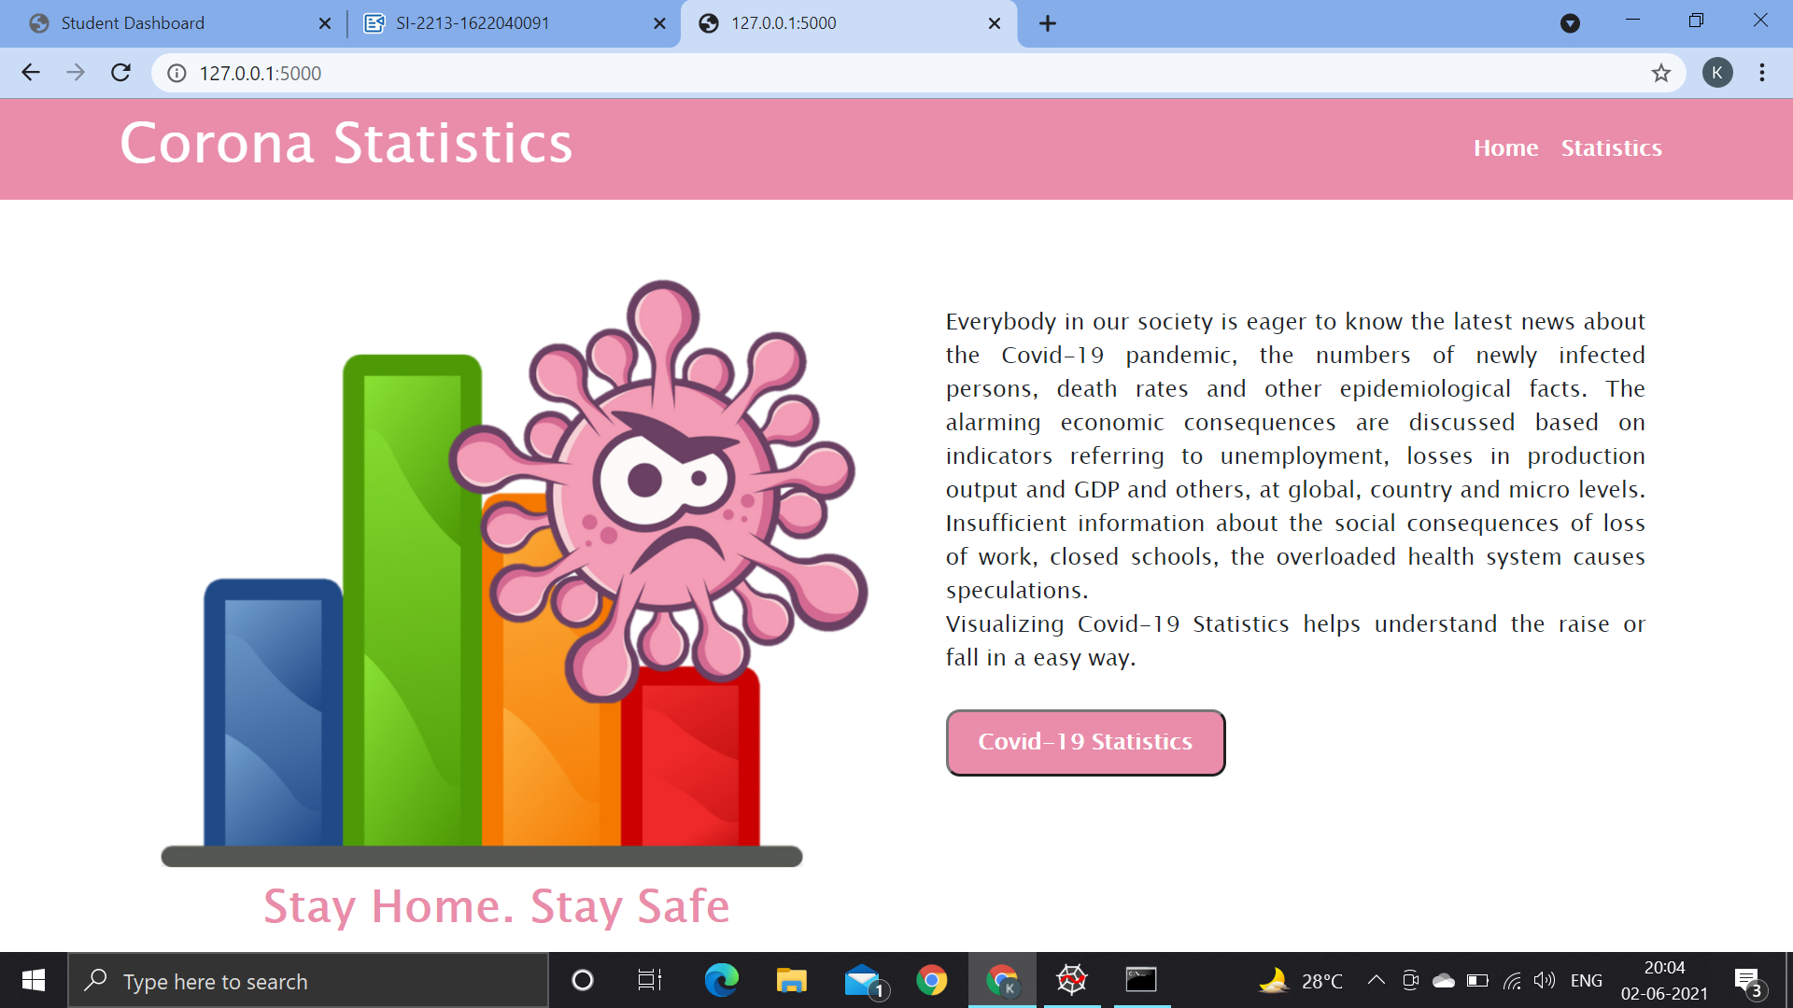

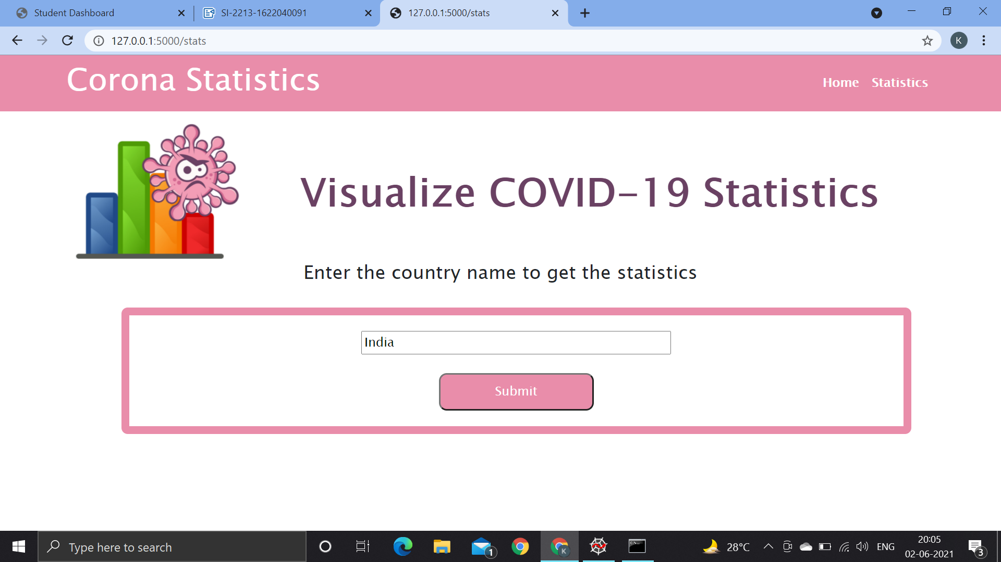

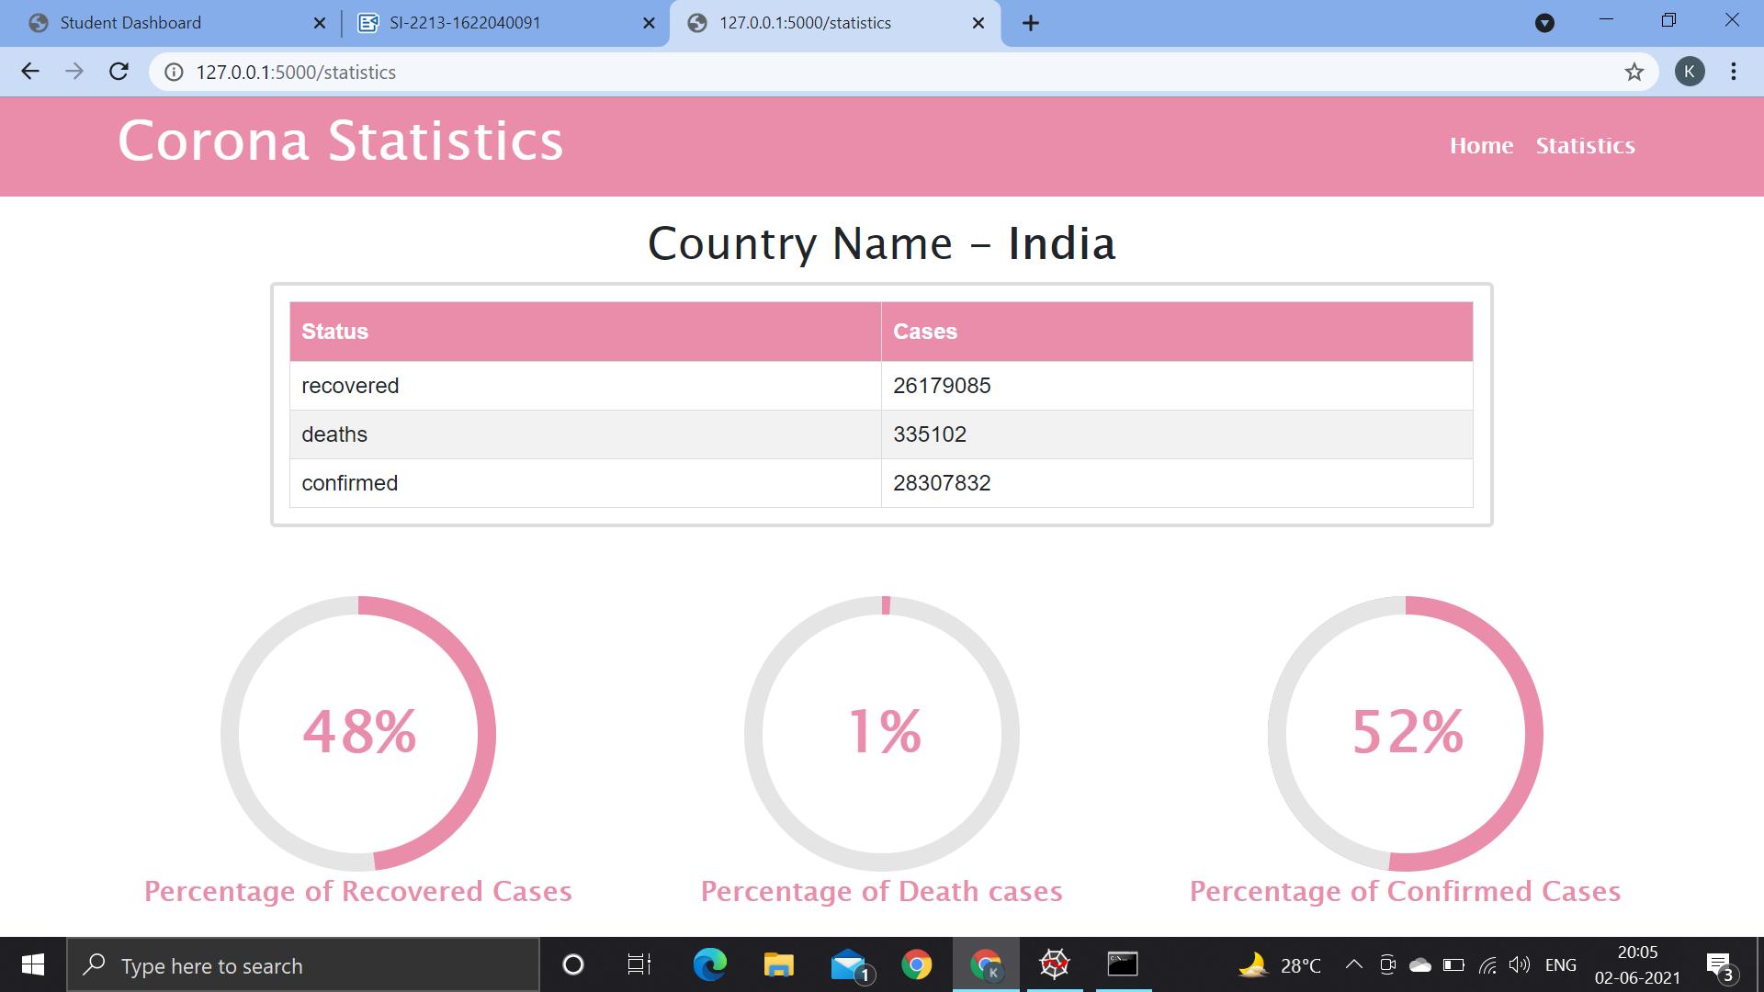

In this case, the input is "**India**" therefore the application shows percentage of recovered, deaths and confirmed cases for India.